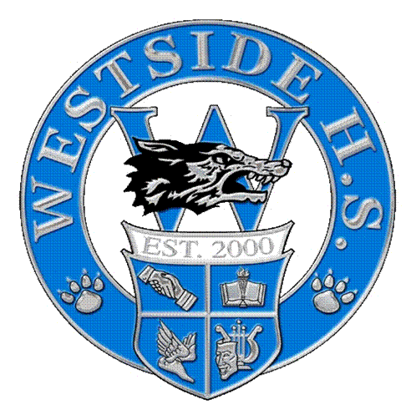
Westside High School Backwards-Design Lesson Plan Template
2017-2018

IPC-Integrated Physics and Chemistry
Froehlich
Unit 3A—Properties of Matter-Part 2

Stage 1 – Desired Results
Understanding (s)/goals: | Essential Question(s): | Student Outcomes (objectives):
EU1: Students identify, memorize, recall, organize, relate, practice and explain mass, volume and density | EQ1: How are mass and volume related to density? | SO1.1: IPC 7-The student knows that changes in matter affect everyday life.  SO1.2: IPC 6C-analyze physical and chemical properties of elements and compounds such as color, density, viscosity, buoyancy, boiling point, freezing point, conductivity, and reactivity;  SO1.3:  SO1.4:
EU2: Students can collect measurements for and arrange, analyze, calculate and explain mathematical equations using mass, volume and density | EQ2: How can I find the mass, volume and density of an object? | SO2.1: IPC 7 1A-demonstrate safe practices during laboratory and field investigations; and  SO2.2: IPC 2B-plan and implement investigative procedures, including asking questions, formulating testable hypotheses, and selecting equipment and technology;  SO2.3: IPC 2C-collect data and make measurements with precision  SO2.4: IPC 2D-organize, analyze, evaluate, make inferences, and predict trends from data  SO2.5: IPC 2E-communicate valid conclusions
EU3: Students identify, recognize, compare/contrast, associate, determine ways IPC prepares them for trades and careers as well as how it relates to everyday life. | EQ3: How does science (IPC) prepare you for trades, careers, work, and relate to everyday life? | SO3.1: IPC 3E- describe connections between physics and chemistry and future careers;  SO3.2: IPC 3D-evaluate the impact of research on scientific thought, society, and the environment;  SO3.3: IPC 3C-draw inferences based on data related to promotional materials for products and services;  SO3.4:  SO3.5:
EU4: | EQ4 | SO4.1:  SO4.2:  SO4.3:  SO4.4:
EU5: | EQ5: | SO5.1:  SO5.2:
Stage 2 – Assessment Evidence
Performance Task(s) and Other Evidence: (Assessment evidence should be collected for each Student Outcome (SO) listed above.)
 | Formative |  | Summative (Attach copy)
SO1.1-1.2 | Check for Understanding Question in Notes  Wksht: Conceptual Density  Wksht: Density Problems  Lab Activity: Finding Mass, Volume and Density  Unit 3A Test Review | Unit 3A Test
SO1.
SO1.
SO1.
SO2.1-2.5 | Wksht: Conceptual Density  Wksht: Density Problems  Lab Activity: Finding Mass, Volume and Density  Unit 3A Test Review | Unit 3A Test
SO2.
SO2.3,4
SO3.1-3.3 | Interest Survey  Informal discussions over short videos on IPC connections to real-life situations and careers | Commitment to trade or career
SO3.
SO3.
SO4.1-4
SO4.
SO5.1
SO 5.2

